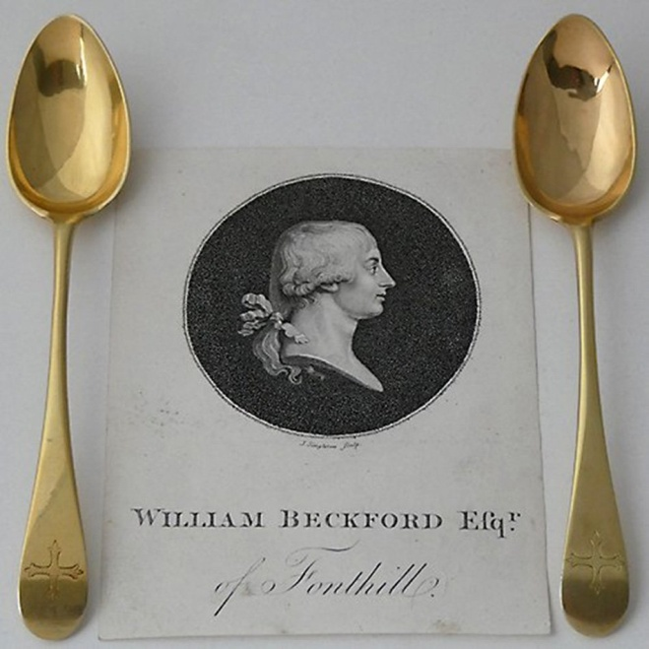
This is your Complimentary Ticket for up to 4 people to
PETERSFIELD
ANTIQUES FAIR
4th – 6th September 2026
Friday to Sunday, 10.30am – 5pm

Festival Hall, Heath Road, Petersfield GU31 4EA
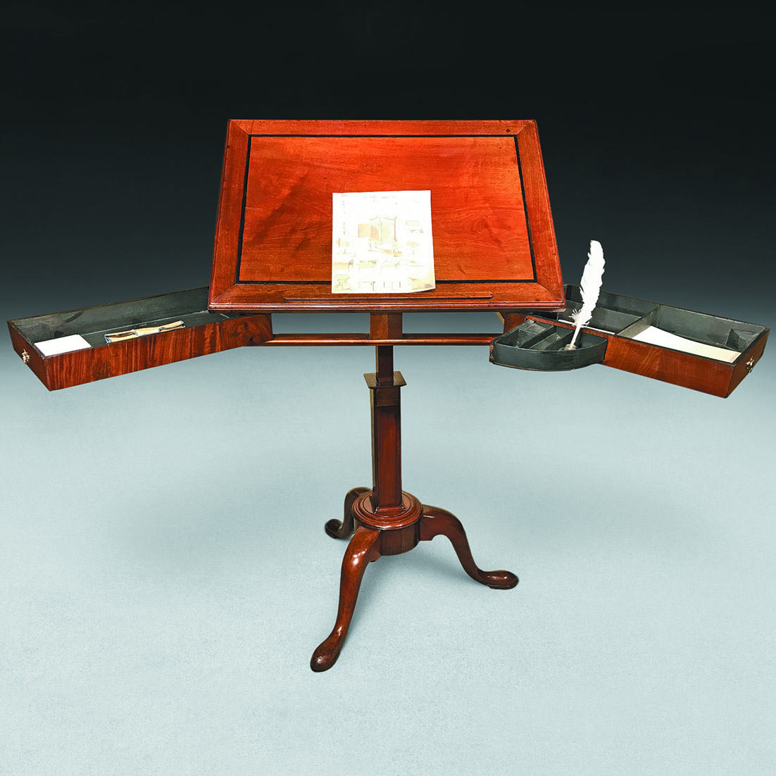
From Schredds of London
(www.schredds.com)

Please print and hand in the page at Reception,
or simply show it on your phone.

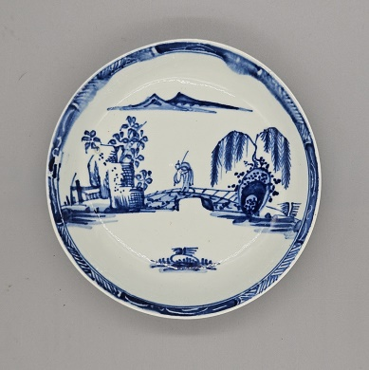
35 dealers including
Bank House Antiques Berlin Walls Gallery
Lesley Blackford Malcolm Bowdery
Mark Buckley Class Antiques
Ben Cooper Dansk Silver
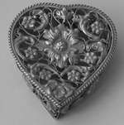
John Ebdon Frodsham Clocks

Garret & Hurst Jill Gosling
Granta Fine Art Hickmet Fine Arts
In Vogue (Martin Lister) StephenKalms
Jeroen Markies Andy Maule
Melody Antiques Petersfield Bookshop
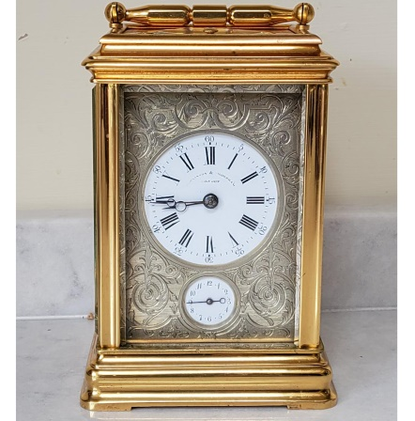
Plaza Jewellery Terry Robert
Schredds of London Shapiro &Company
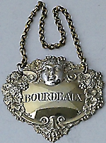
David Scriven Morgan Strickland
Michael St John Joscelyn Vereker

Organised by Ben Cooper,

T: 07774 850044. info@penman-fairs.co.uk

The next fair will be on March 5th-7th 2027



